**SQL Assignment 1**

**1. Write a query to get a Product list (id, name, unit price) where current products cost less than $20.**

select ProductID, ProductName, UnitPrice from products where UnitPrice<=20 and Discontinued=0;

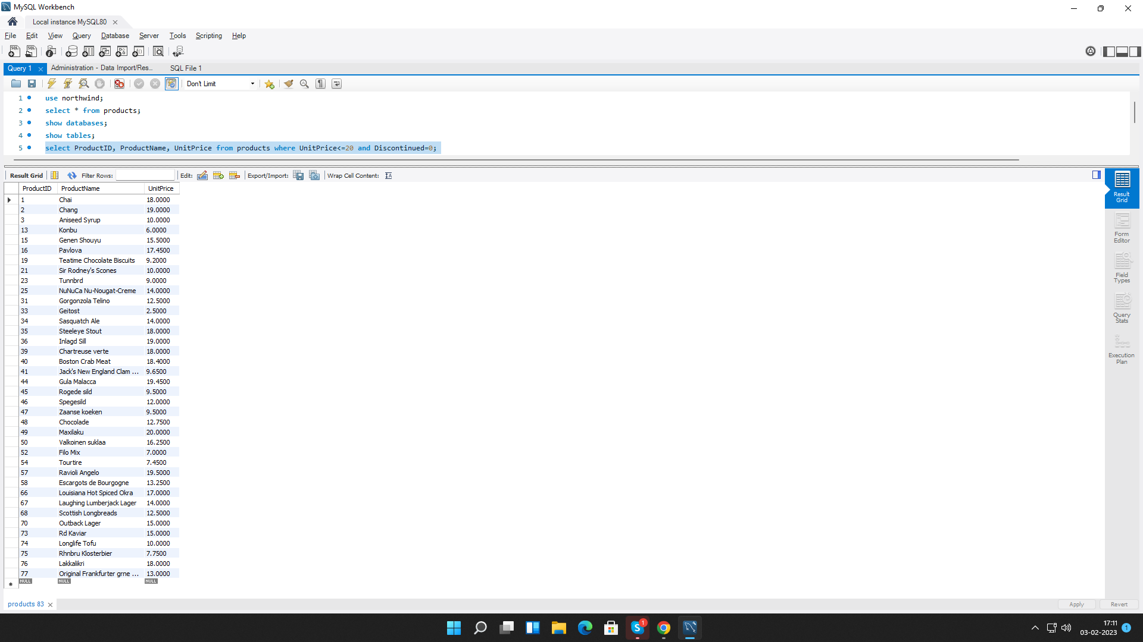

**2. Write a query to get Product list (id, name, unit price) where products cost between $15 and $25.**

select ProductID, ProductName, UnitPrice from products where UnitPrice between 15 and 25;

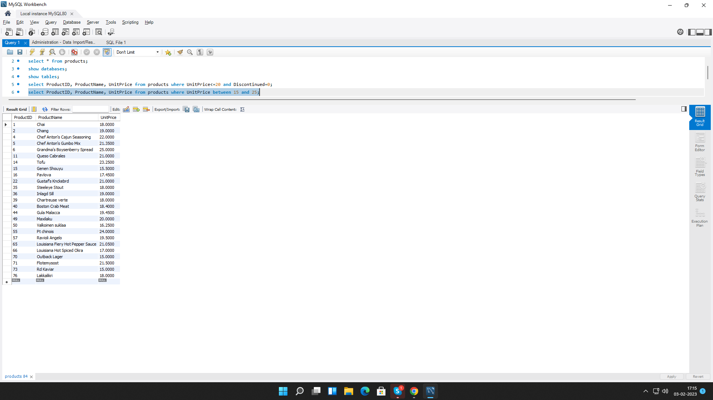

**3. Write a query to get Product list (name, unit price) of above average price.**

select ProductName, UnitPrice from products where UnitPrice> (select AVG(UnitPrice) from products);

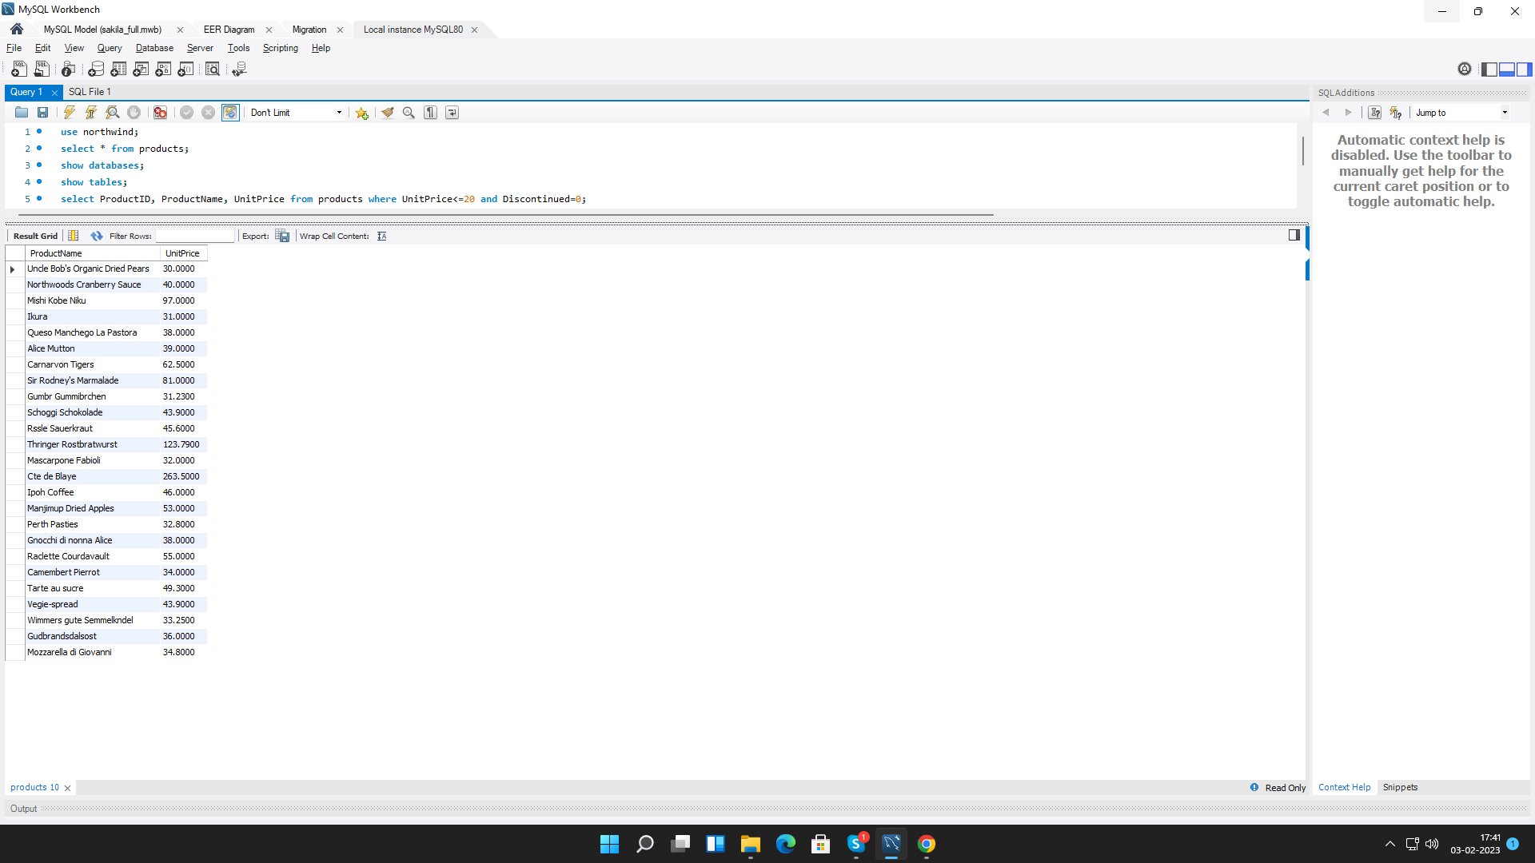

**4. Write a query to get Product list (name, unit price) of ten most expensive products.**

select ProductName, UnitPrice from products order by UnitPrice desc limit 10;

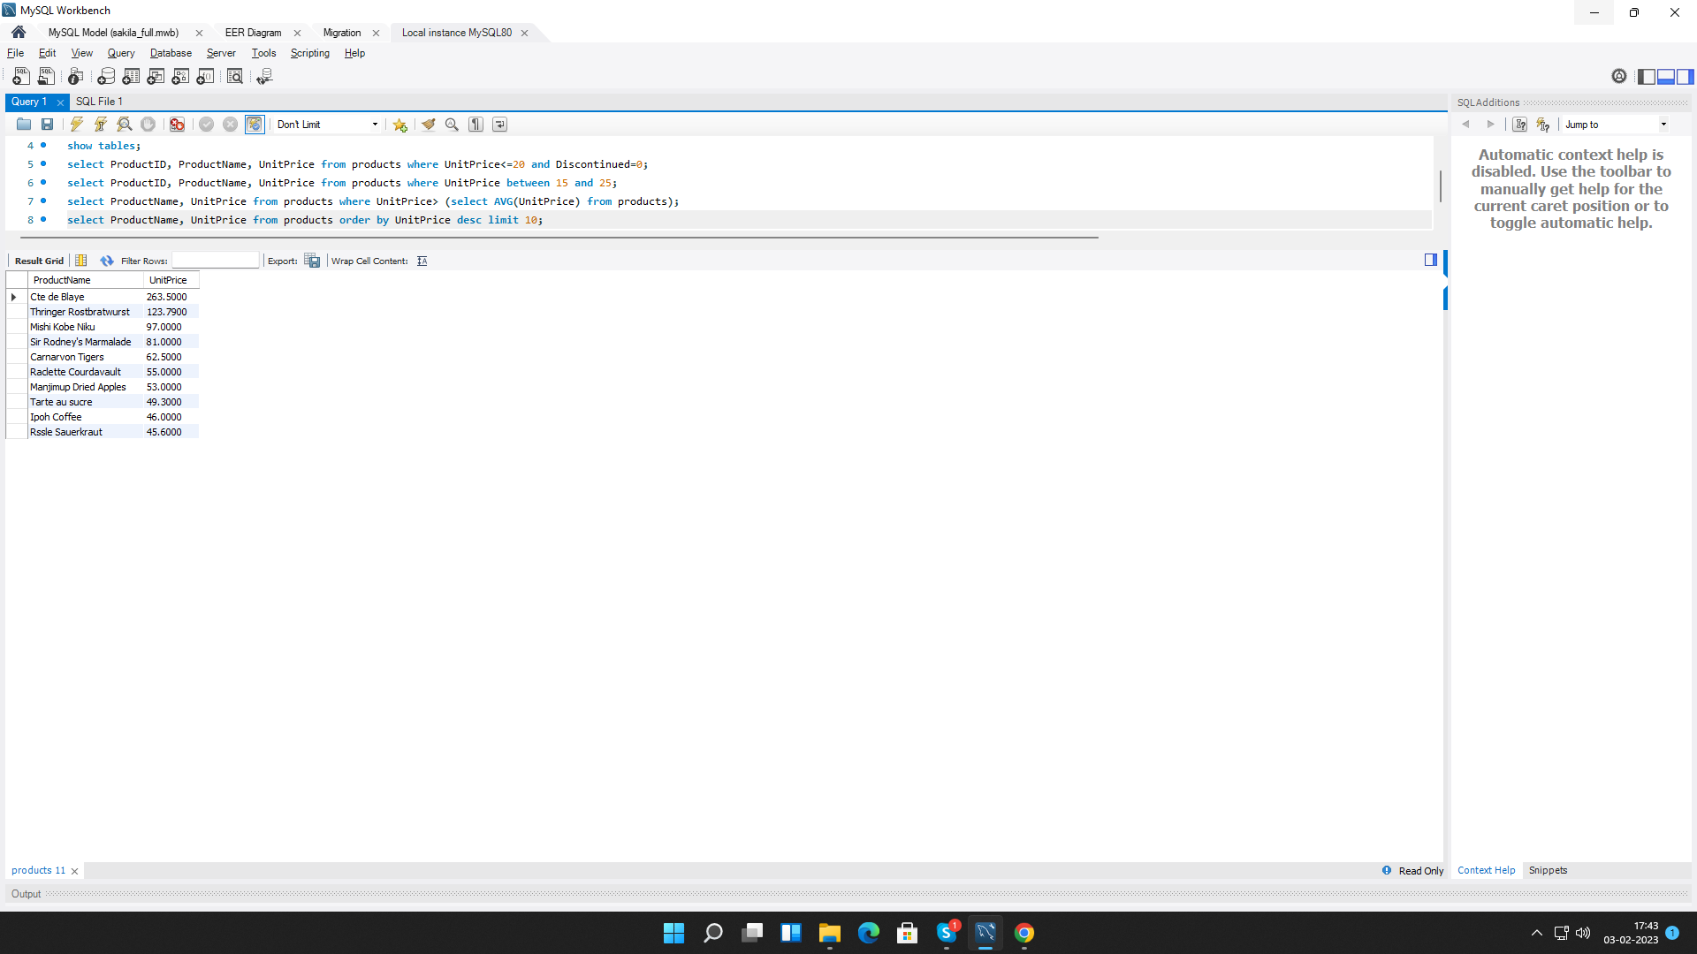

**5. Write a query to count current and discontinued products.**

select COUNT(ProductID),Discontinued from products GROUP BY Discontinued;

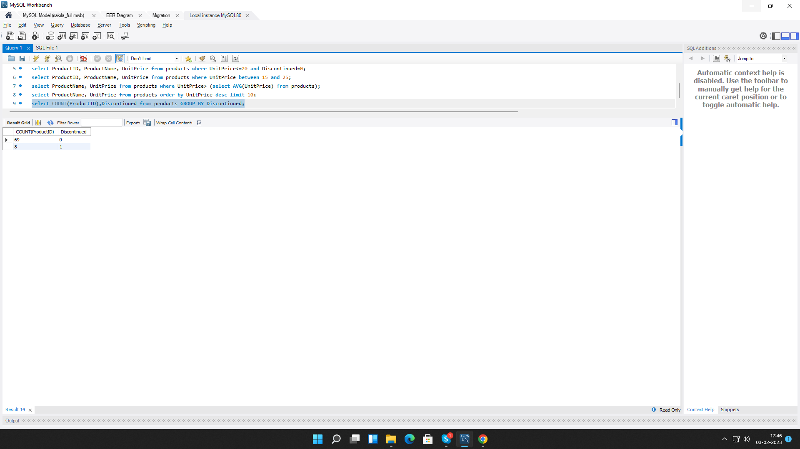

**6. Write a query to get Product list (name, units on order , units in stock) of stock is less than the quantity on order.**

select ProductName,UnitsOnOrder,UnitsInStock from products where UnitsInStock<UnitsOnOrder;

